**ECEGR 2220: Microprocessor Design**

**Spring 2018**

**LAB 2 REPORT**

**Name: Don-Thuan Le**

**Performed by:**

**Don-Thuan Le - Thanh Nguyen – Lauren Molina**

**Date of Report: 04/28/2018**

**SEATTLE UNIVERSITY**

**Department of Electrical and Computer Engineering**

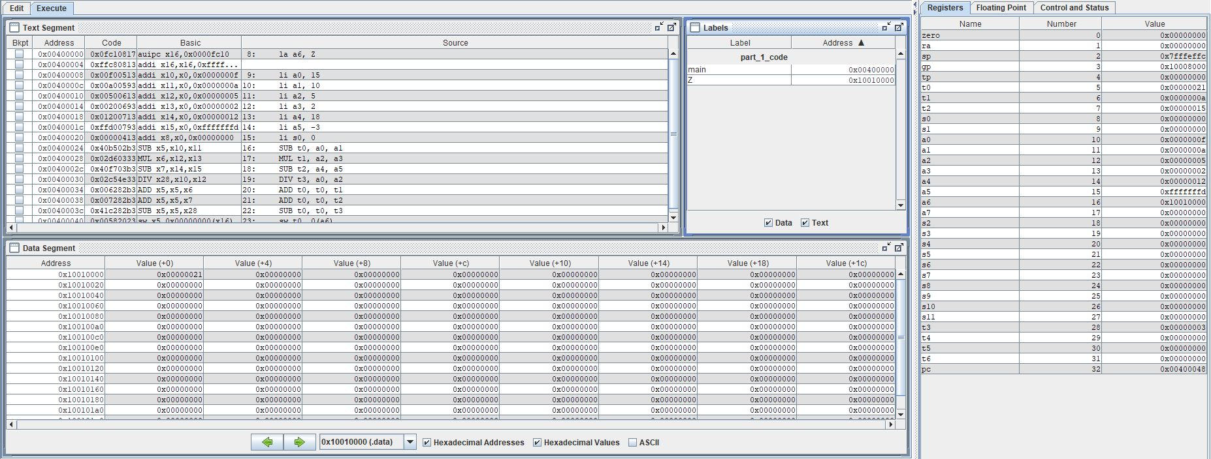

The screen shot above is the results of running the rars simulation program using the code for part 1 of the lab. From the labels tab, you can see Z is saved in memory. In addition, the value of Z in the end is 33 in decimal which is the correct sum of the given numbers.

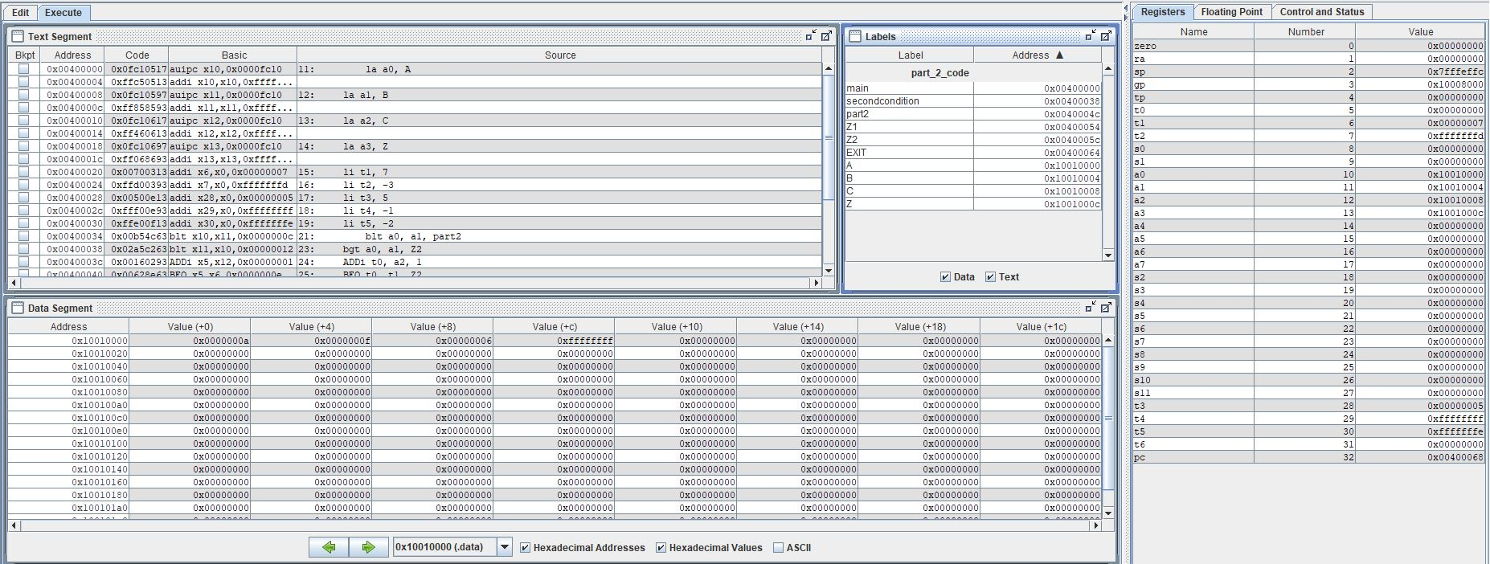

The screen shot above is the results of running the rars simulation program using the code for part 2 of the lab. From the labels tab, you can see that A, B, C, and Z are all saved in memory. Their values can also be seen in the data segment with Z giving the correct results.

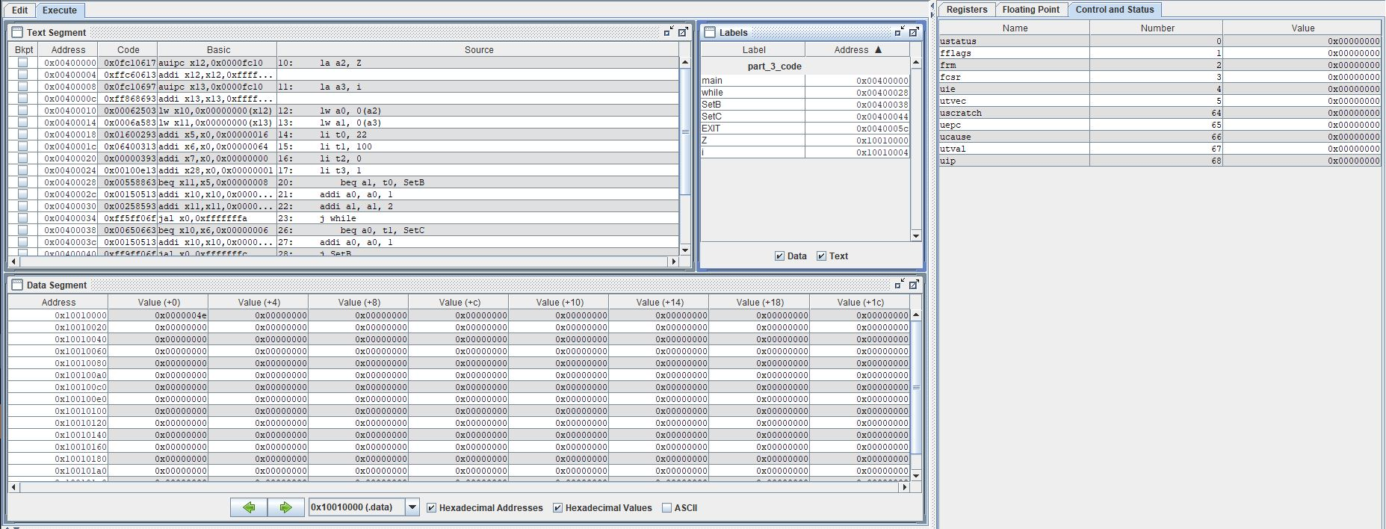

The screen shot above is the results of running the rars simulation program using the code for part 3 of the lab. From the labels tab you can see that Z and I are both saved in memory. In the data segment the value of Z is shown as 78 in decimal which is correct number that Z should end on before the break in code.